*--Report #1: P5.11c*

**SELECT** T_TaskDescription_TK **AS** `Project Task`,

D_TaskStartDate_PS **AS** `**Start** Date`,

D_TaskEndDate_PS **AS** `**End** Date`,

T_SkillDescription_SK **AS** `Skill`,

Switch(

T_FirstName_EP **IS** **NOT** **NULL**, C_AssignmentID_AS & '-' & T_FirstName_EP & ' ' & **LEFT**(T_LastName_EP, 1) & '.',

T_FirstName_EP **IS** **NULL**, ''

) **AS** `Employee`,

D_AssignmentStartDate_AS **AS** `Actual **Start** Date`,

D_AssignmentEndDate_AS **AS** `Actual **End** Date`

**FROM**

((((Task t

**LEFT** **JOIN** ProjectSchedule ps **ON** ps.C_TaskID_PS = t.C_TaskID_TK)

**LEFT** **JOIN** **Assignment** a **ON** a.C_TaskID_AS = t.C_TaskID_TK)

**LEFT** **JOIN** Skill s **ON** s.C_SkillID_SK = a.C_SkillID_AS)

**LEFT** **JOIN** Employee e **on** e.C_EmployeeID_EP = a.C_EmployeeID_AS)

**WHERE** C_ProjectID_PS = 1

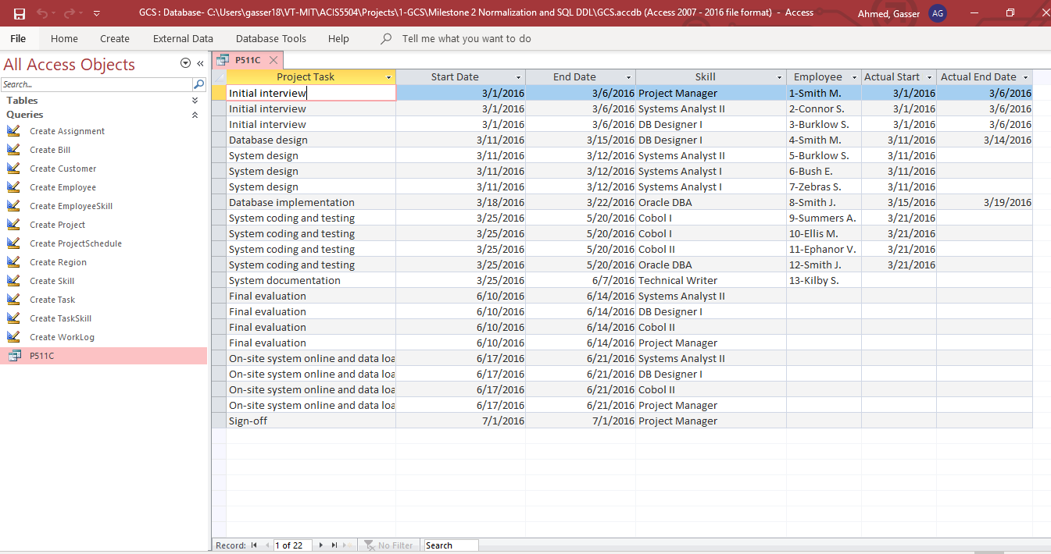**ORDER** **BY** C_TaskID_TK, C_AssignmentID_AS;

*--Report #2: P5.11A*

*Description:* Each employee has many skills, and many employees have the same

skill. The screenshot below shows an example of the Skills Inventory.

*Query:*

**SELECT** T_SkillDescription_SK **AS** `Skill`,

T_FirstName_EP & ' ' & T_LastName_EP **AS** `Employee`

**FROM**

(Skill s

**LEFT** **JOIN** EmployeeSkill es **on** es.C_SkillID_ES = s.C_SkillID_SK)

**LEFT** **JOIN** Employee e **on** e.C_EmployeeID_EP = es.C_EmployeeID_ES

**ORDER** **BY** C_SkillID_SK

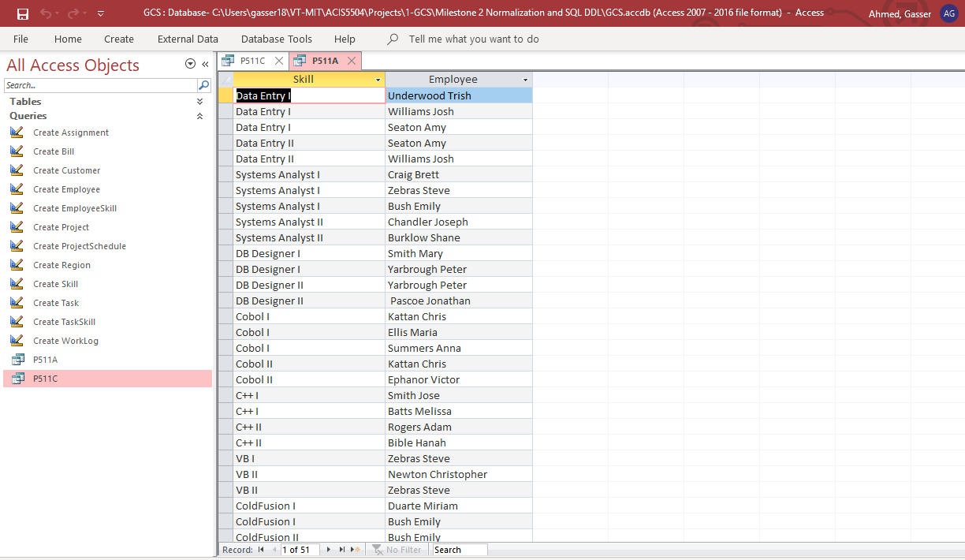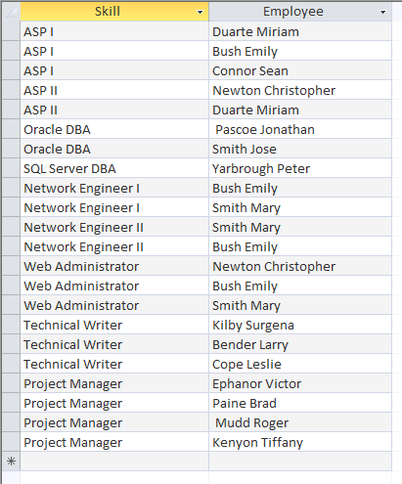

*--Report #3: P5.11D*

*Description:* Employee work hours are kept in a work log, which contains a record of the actual hours worked by employees on a given assignment. The work log is a form that the employee fills out at the end of each week (Friday) or at the end of each month. The form contains the date, which is either the current Friday of the month or the last workday of the month if it does not fall on a Friday. The form also contains the assignment ID, the total hours worked either that week or up to the end of the month, and the bill number to which the work-log entry is charged. A sample list of the current work-log entries for the first sample project is shown in the screenshot below.

*Query:*

**SELECT** T_FirstName_EP & ' ' & **LEFT**(T_LastName_EP, 1) & '.' **AS** `Employee Name`,

D_WeekEndingDate_WL **AS** `Week Ending`,

C_AssignmentID_WL **AS** `**Assignment** Number`,

N_HoursWorked_WL **AS** `Hours Worked`,

C_BillID_WL **AS** `Bill Number`

**FROM**

((WorkLog wl

**LEFT** **JOIN** **Assignment** a **on** a.C_AssignmentID_AS = wl.C_AssignmentID_WL)

**LEFT** **JOIN** Employee e **on** e.C_EmployeeID_EP = a.C_EmployeeID_AS)

**LEFT** **JOIN** ProjectSchedule ps **on** ps.C_TaskID_PS = a.C_TaskID_AS

**WHERE** C_ProjectID_PS = 1

**ORDER** **BY** C_WorkLogID_WL;

